**ECE3502 – IoT Domain Analyst**

**LAB – 11. RStudio to Node Red data transfer**

**Name: Varun Patel**

**Reg. No.: 18BCE1204**

**Faculty: Prof. Rekha D.**

**Date: 01-06-2021**

**Q1. Linear Regression.**

**Generate 2 random values (height, weight) on Node Red and store them onto a csv file. Take this dataset into RStudio and generate a linear regression model to predict height at a given weight value. Send this predicted output to Node Red to display on dashboard.**

**Ans.**

**Node Red flow:**

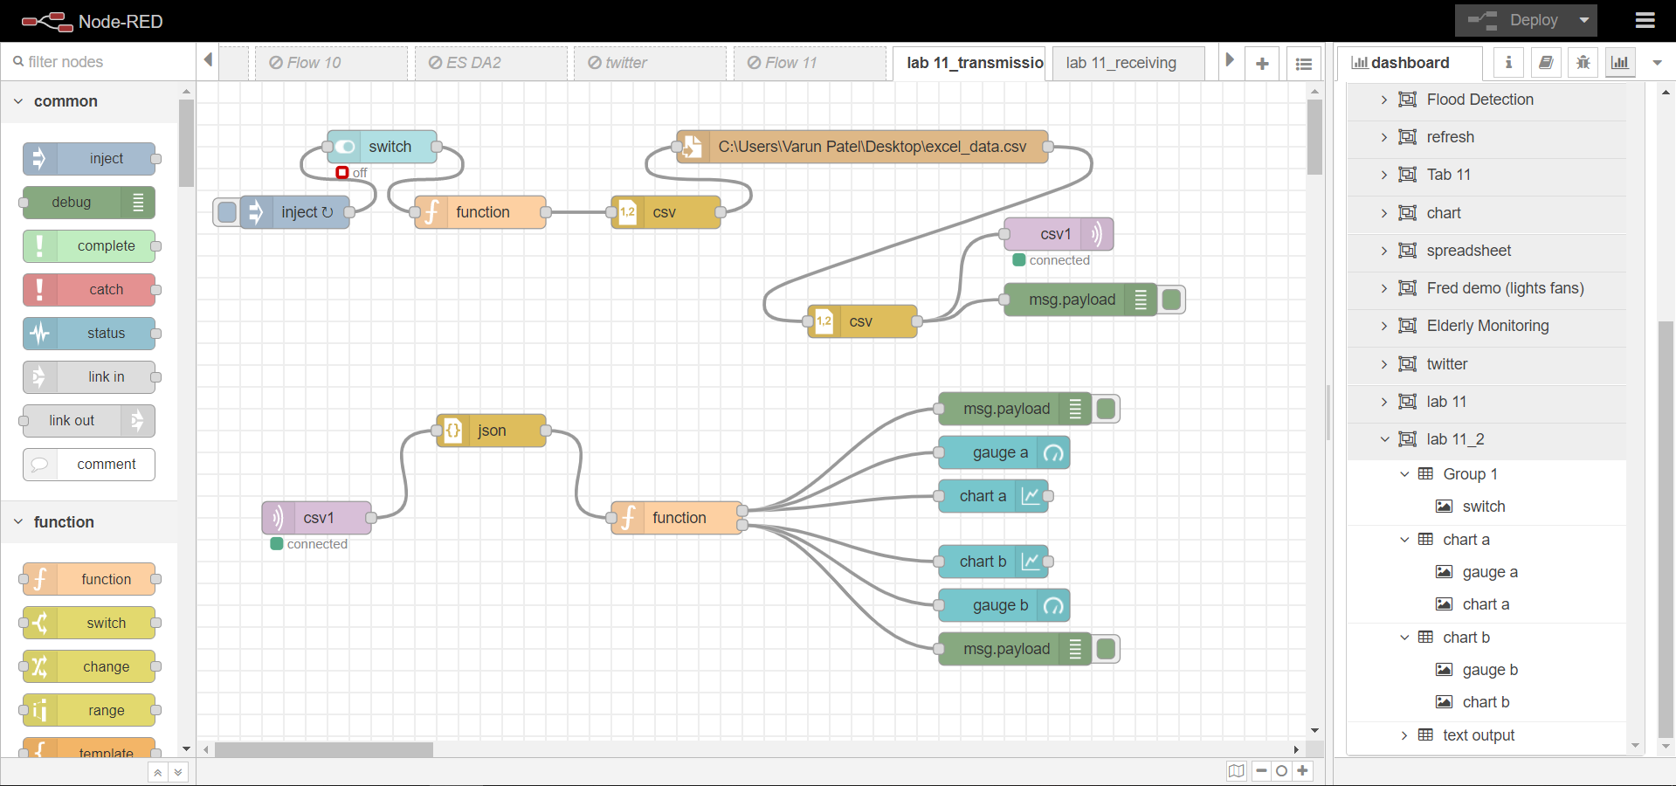

**Dataset (2 random numbers between 1 – 100):**

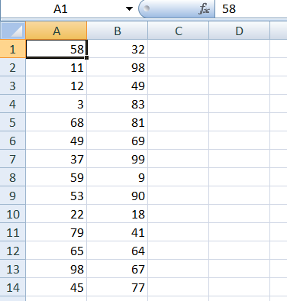 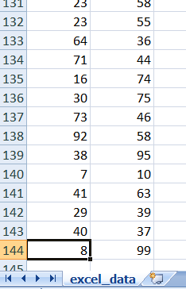

**RStudio (Script Code):**

#put csv file in current working directory("Documents")

#create dataframe of csv file

setwd("C:/Users/Varun Patel/Desktop")

print(getwd())

hw <- read.csv("excel_data.csv", header = FALSE)

#print(hw)

#separating columns into dataframes

h1 <- hw$V1

w1 <- hw$V2

#print(h1)

#plot graphs

plot(x=h1, y=w1)

#linear regression model

model_hw <- lm(h1 ~ w1)

summary(model_hw)

**Screenshots:**

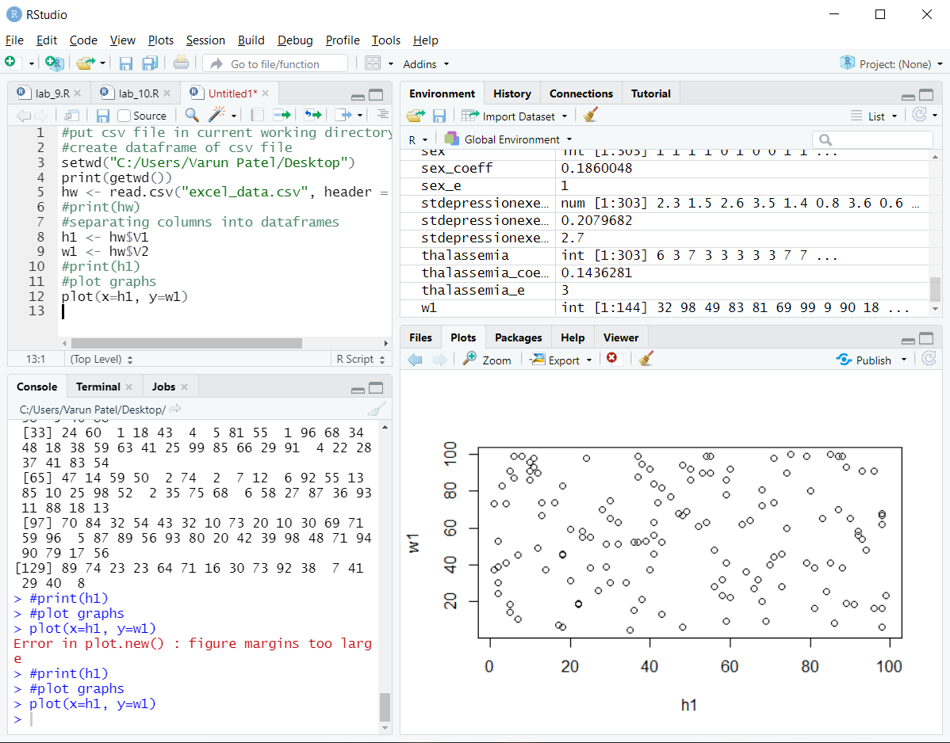

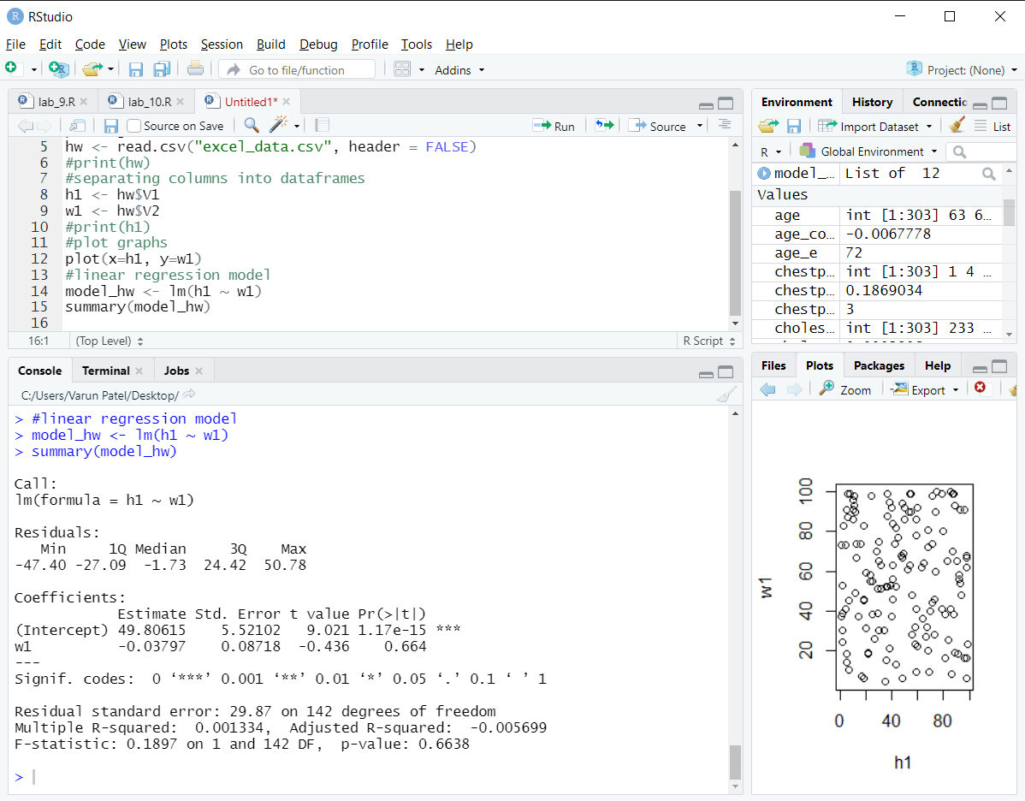

**Console Code (Prediction and saving output in a .txt file):**

> # save output in file

> sink(file = "pred.txt")

> print("#prediction")

> print(intercept:)

Error: unexpected ')' in "print(intercept:)"

> print("intercept:")

> intercept = 49.80615

> intercept

> print("w coefficient:")

> w_coeff = -0.03797

> w_coeff

> # w random value

> w_rand = 37

> print("w random value:")

> w_rand

> h_pred = (intercept) + (w_coeff)*(w_rand)

> print("predicted h:")

> h_pred

> sink(file = NULL)

**Output:**

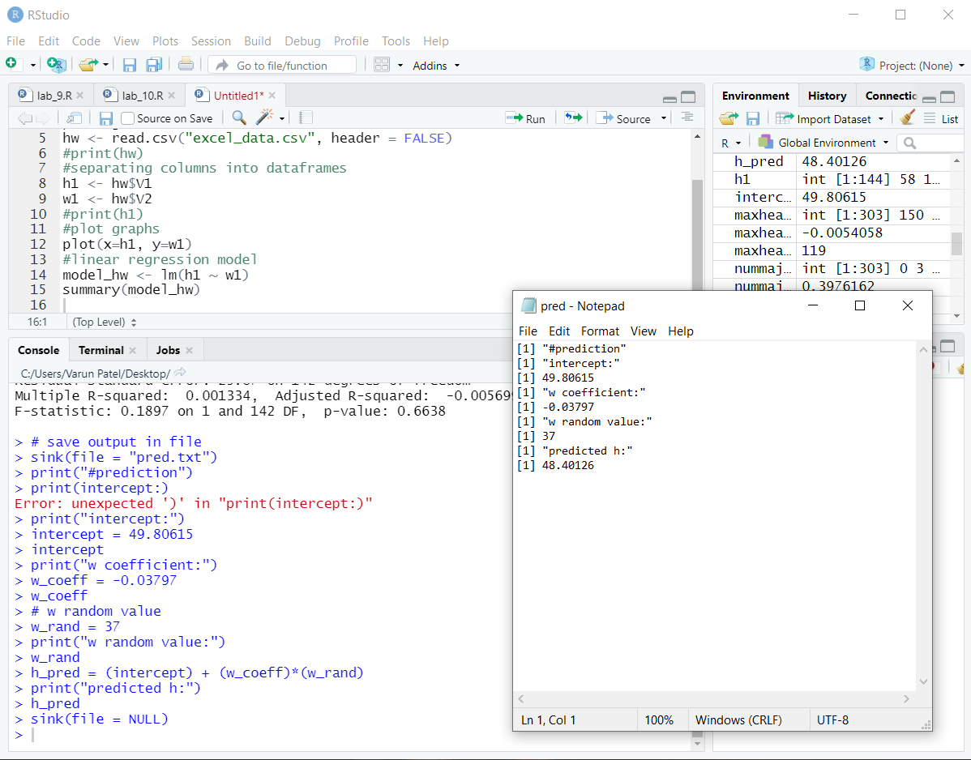

**Node Red flow for receiving data and display on dashboard:**

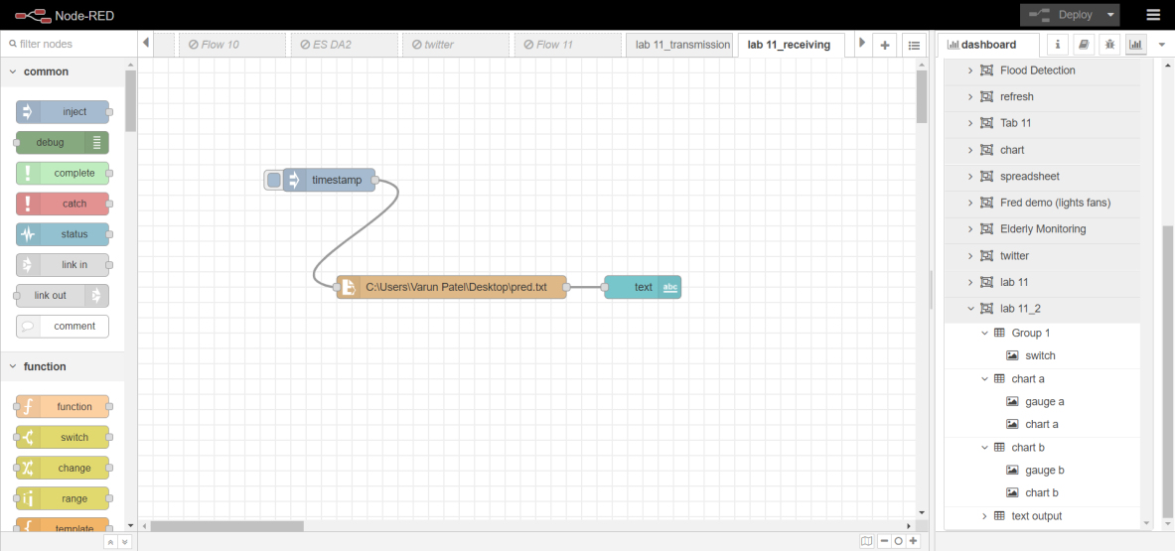

**Dashboard output:**

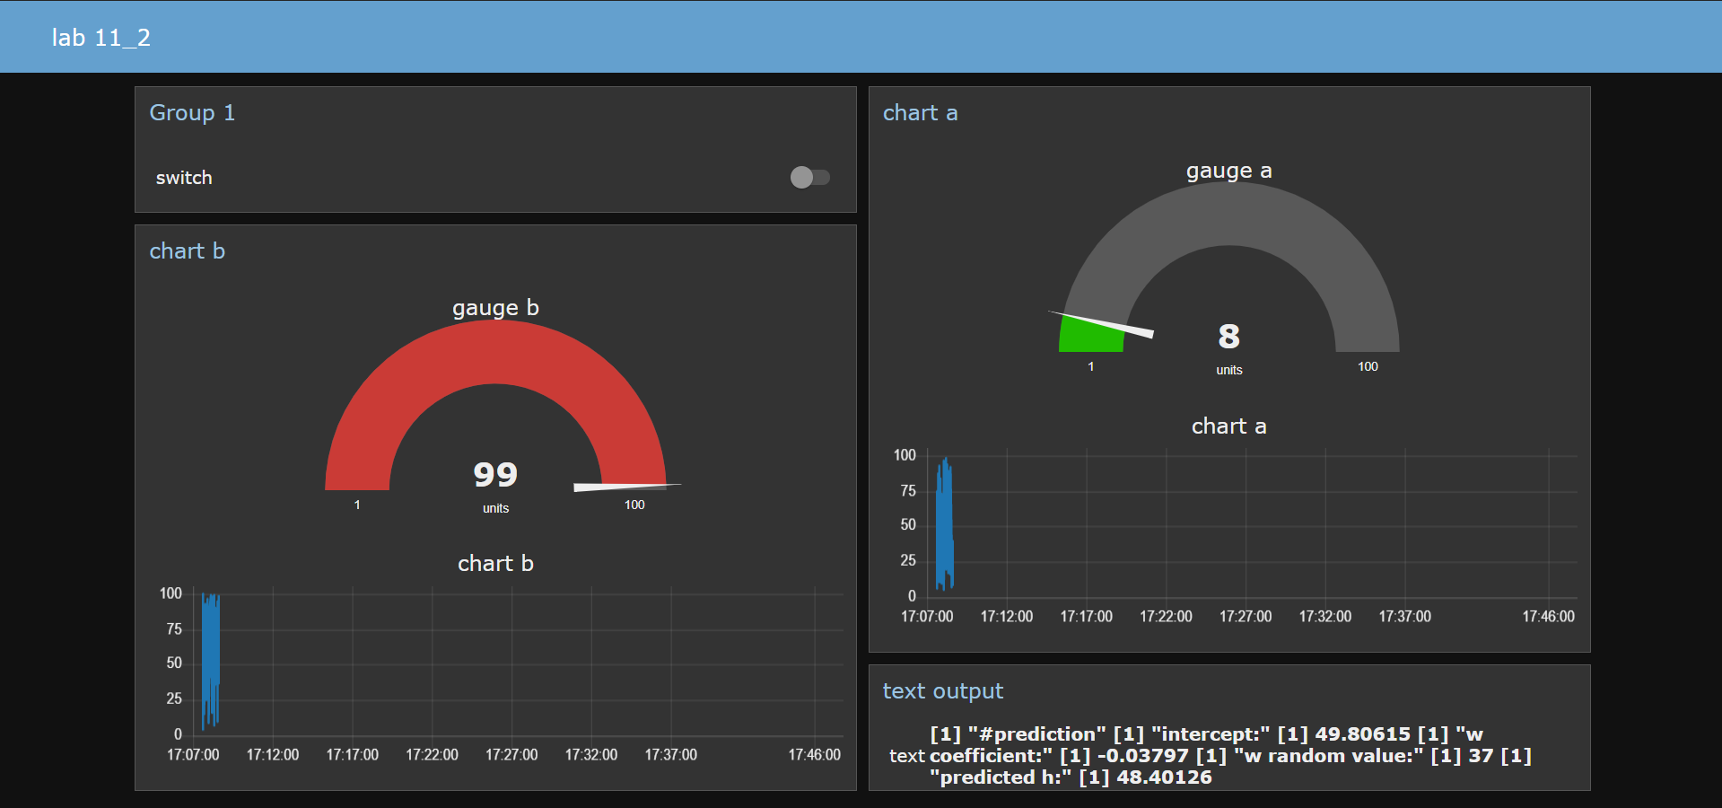

**Q2. Multiple Linear Regression.**

**Generate 8 random values (date, time, location, humidity, temperature, soil_moisture, light_intensity, production) on Node Red and store them onto a csv file. Take this dataset into RStudio and generate a multiple linear regression model to predict production at given values of the independent variables (date, time, location, humidity, temperature, soil_moisture, light_intensity). Send this predicted output to Node Red to display on dashboard.**

**Ans.**

**Node Red flow:**

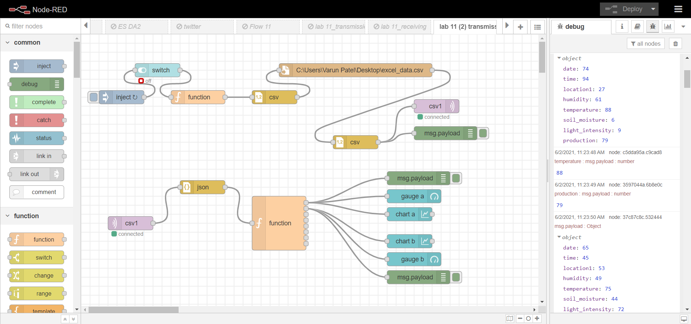

**Function node (value generation):**

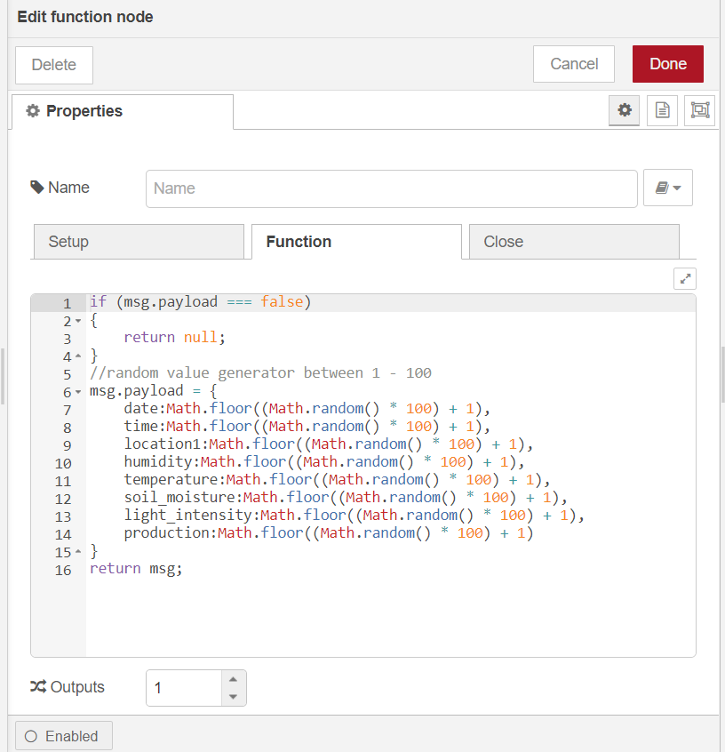

**Function node (collection):**

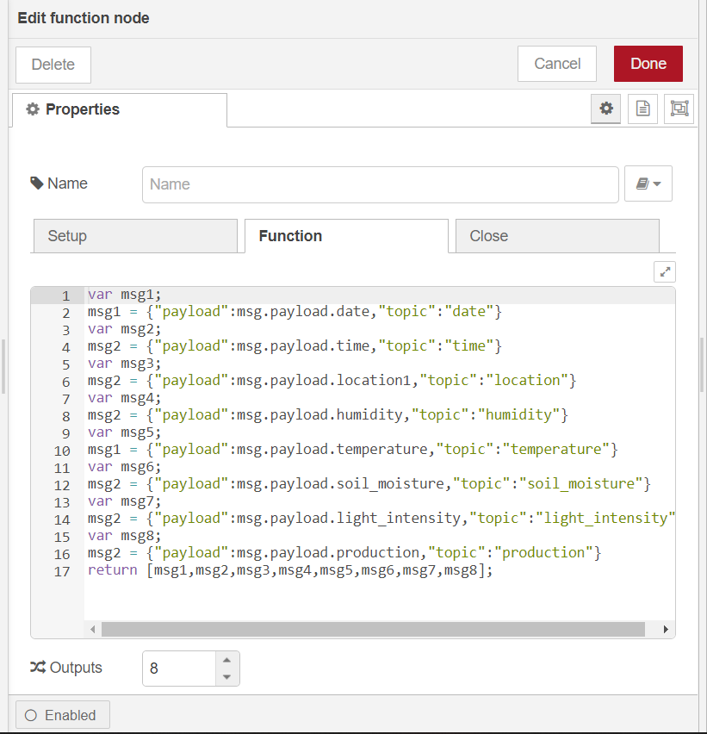

**Dataset:**

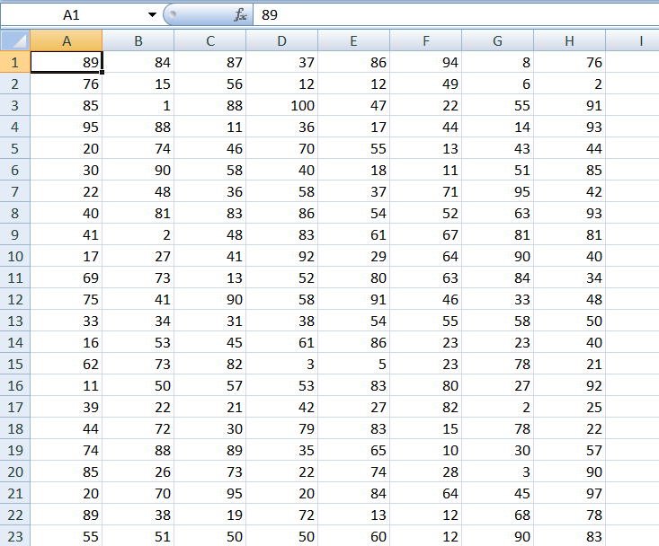 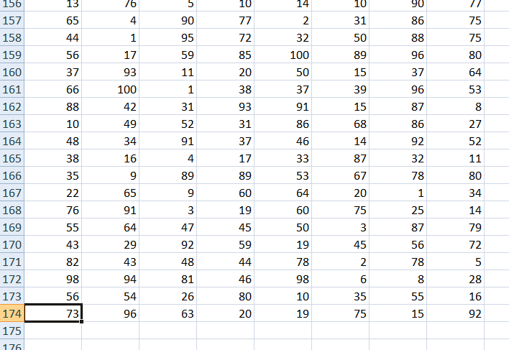

**RStudio (Script Code):**

#put csv file in current working directory("Documents")

#create dataframe of csv file

setwd("C:/Users/Varun Patel/Desktop")

print(getwd())

plant <- read.csv("excel_data.csv", header = FALSE)

#print(plant)

#separating columns into dataframes

date <- plant$V1

time <- plant$V2

location <- plant$V3

humidity <- plant$V4

temperature <- plant$V5

soil_moisture <- plant$V6

light_intensity <- plant$V7

production <- plant$V8

#plot graphs

plot(x=production, y=temperature)

plot(x=production, y=light_intensity)

#multiple linear regression model

plant_model <- lm(production ~ date + time + location + humidity + temperature + soil_moisture + light_intensity)

summary(plant_model)

**Screenshots:**

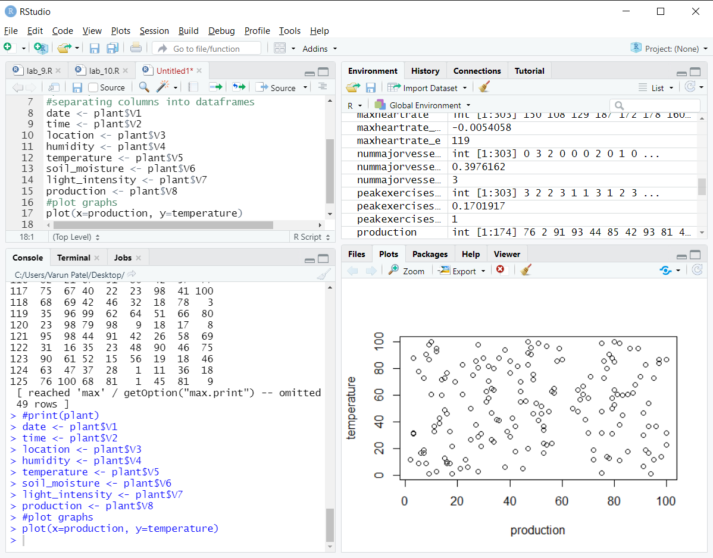

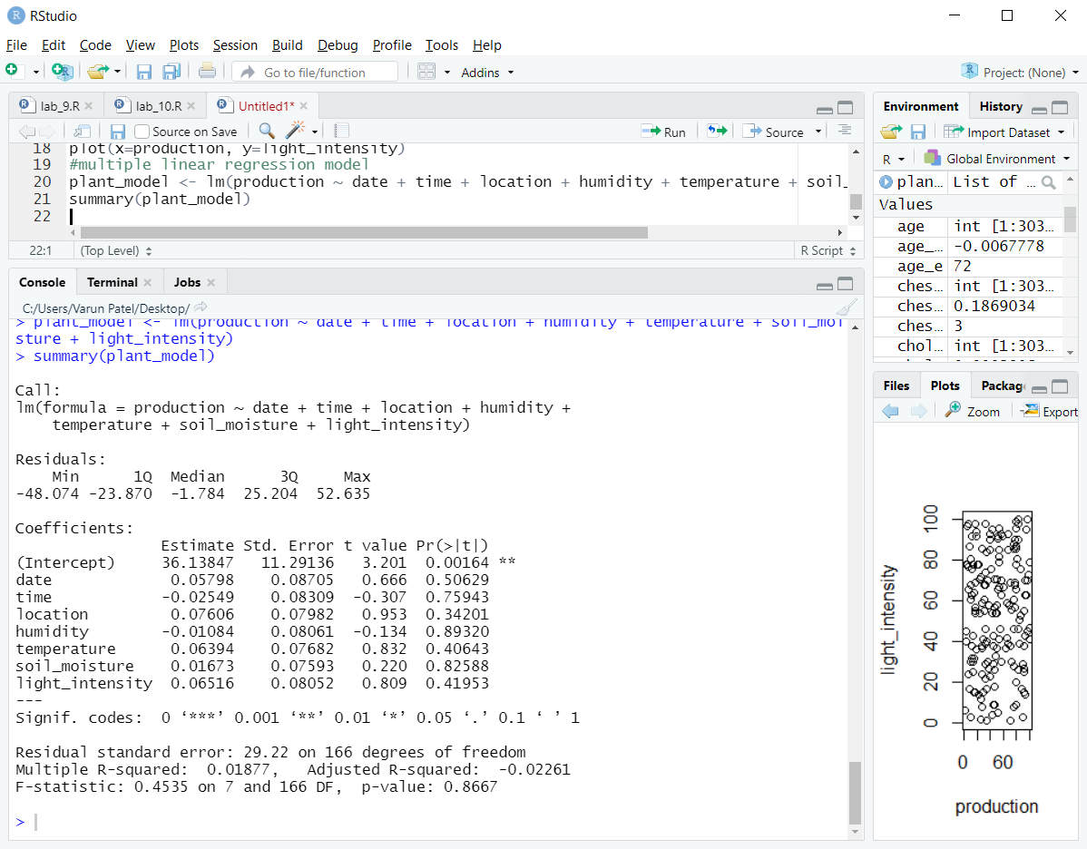

**Console Code (Prediction and saving output in a .txt file):**

> sink(file = "lab_11_plant.txt")

> print("Model summary")

> intercept = 36.13847

> cat("Intercept: " , intercept, "\n")

> date_coeff = 0.05798

> cat("Date coeff: " , date_coeff, "\n")

> time_coeff = -0.02549

> cat("Time coeff: " , time_coeff, "\n")

> location_coeff = 0.07606

> cat("Location coeff: " , location_coeff, "\n")

> humidity_coeff = -0.01084

> cat("Humidity coeff: " , humidity_coeff, "\n")

> temperature_coeff = 0.06394

> cat("Temperature coeff: " , temperature_coeff, "\n")

> soil_moisture_coeff = 0.01673

> cat("Soil moisture coeff: " , soil_moisture_coeff, "\n")

> light_intensity_coeff = 0.06516

> cat("Light intensity coeff: " , light_intensity_coeff, "\n")

> # independent variables random values

> print("Random values")

> date_e = 89

> cat("Date: " , date_e, "\n")

> time_e = 12

> cat("Time: " , time_e, "\n")

> location_e = 45

> cat("Location: " , location_e, "\n")

> humidity_e = 65

> cat("Humidity: " , humidity_e, "\n")

> temperature_e = 5

> cat("Temperature: " , temperature_e, "\n")

> soil_moisture_e = 99

> cat("Soil moisture: " , soil_moisture_e, "\n")

> light_intensity_e = 19

> cat("Light intensity: " , light_intensity_e, "\n")

> # prediction

> production_e = (intercept) + (date_coeff)*(date_e) + (time_coeff)*(time_e) + (location_coeff)*(location_e) + (humidity_coeff)*(humidity_e) + (temperature_coeff)*(temperature_e) + (soil_moisture_coeff)*(soil_moisture_e) + (light_intensity_coeff)*(light_intensity_e)

> cat("Predicted production: " , production_e)

> sink(file = NULL)

**Output:**

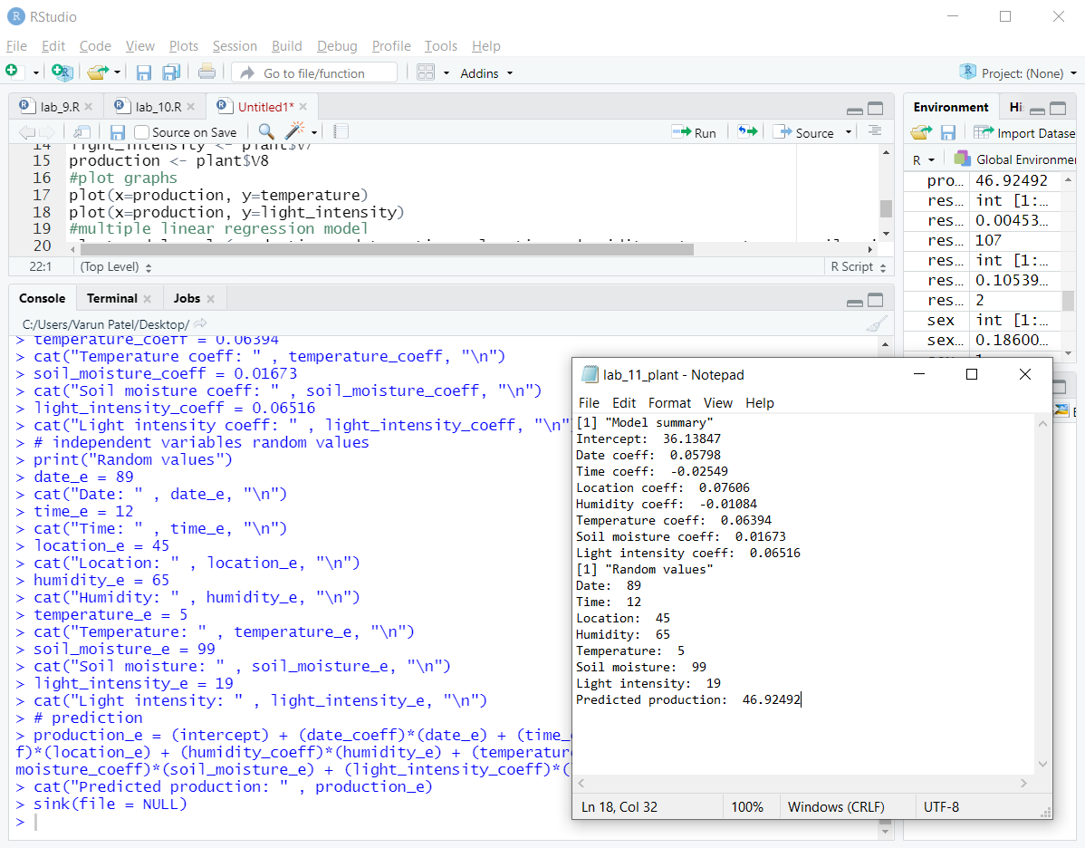

**Node Red output:**

